GIT AND GITHUB VERSION CONTROLS
BTK AKADEMİ

What is git and github?
Git is a version control system. Git and github are two different things. Version control can be explained as "checkpoints" in games.
Created by Linus Torvalds, open-source and free.
Is an endustry standard.
Common Commands
ls - list files (-la - show hidden)(dir for cmd)
pwd - show current directory (cd for cmd)
cd "directory" - choose directory
cd . - choose current directory
cd .. - choose upper directory
clear - clear bash (cls for cmd)
(TAB button) - fills remaining part for "cd **"
mkdir - make directory
touch "file.extension" - create file (type nul > "file.ext" for cmd)
rm "file.extension" - remove file
(del "file.ext" , /f -force, * - wildcard)
rm -rf "directory" - remove directory (rmdir -r)

Set your username and e-mail to git
git config --global user.name "name"
git config --global user.email "mail"

Terms used in Git
Commit - every "checkpoint" created is called commit
Branch - a new "branch" from a certain commit
Work Directory - workstation
Index/Staging - Indexing project before commit (git add)
Local Repository - Commit
Git init, log and status
git init- initialize git
git branch - m "name" - set name of the initial branch
git add "file.ext" - index (git add . for all files)
git commit -m "first commit" - commit named first commit
git log - history
If changes made in the files git status will show changes and notify that these changes are not committed. git add and git commit commands should be used.
if git log is too long traversal in log text will be activated. (END) message will appear. press 'q' to exit.

Gitignore
Create a file named ".gitignore"
type files in .gitignore file and save (*.ext)
no need for command
gitignore templates for projects can be found on the internet

Head and Merge
in statement HEAD -> master, Head states current place of the project (like a pointer). usually shows last commit.
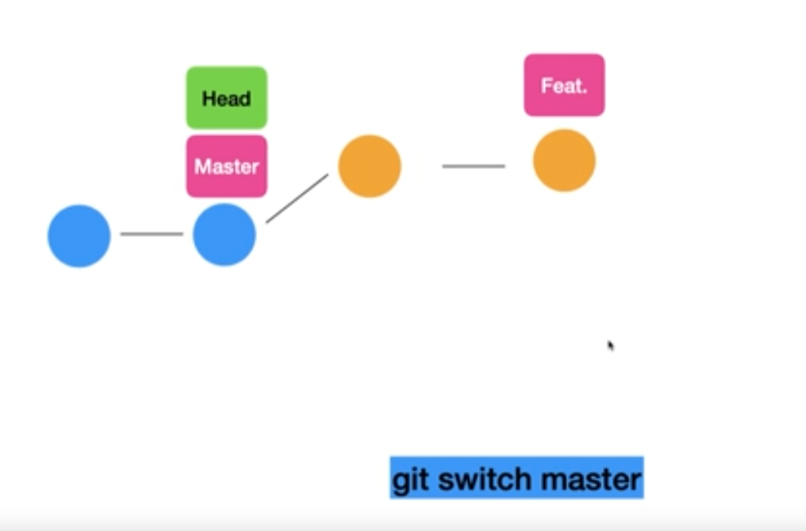
git branch "branch" - creates a branch
git switch "branch" - switchs to a branch
git merge "other branch" - merges current branch and other branch
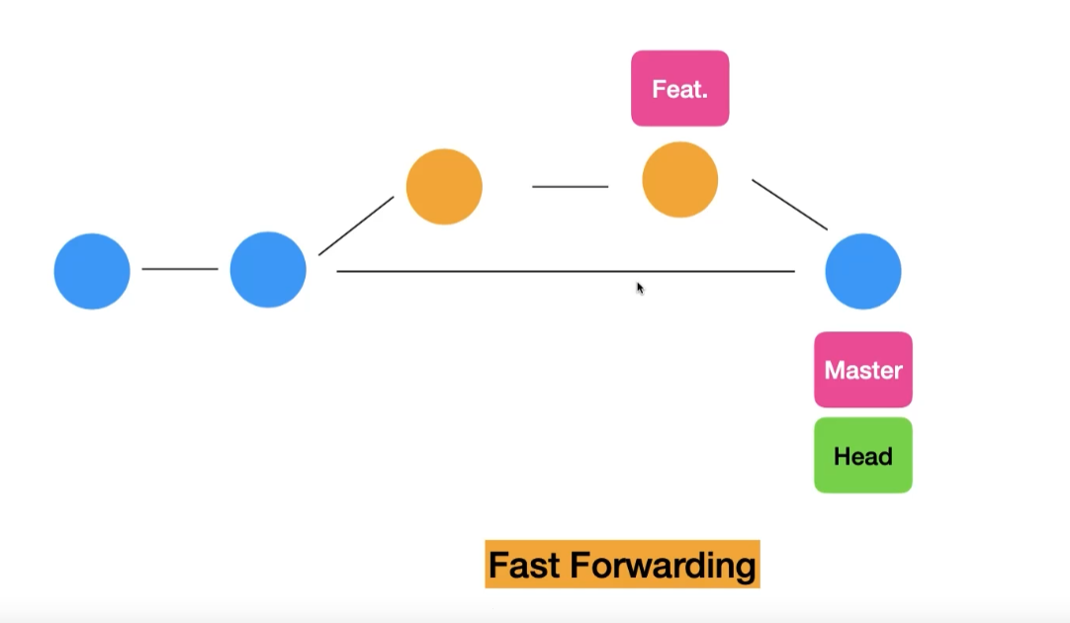

Merge Conflict
Merge operation usually works when files of the branches doesn't conflict. additions to the file, or new files are appropriate but different versions of the same file are what arises conflict.
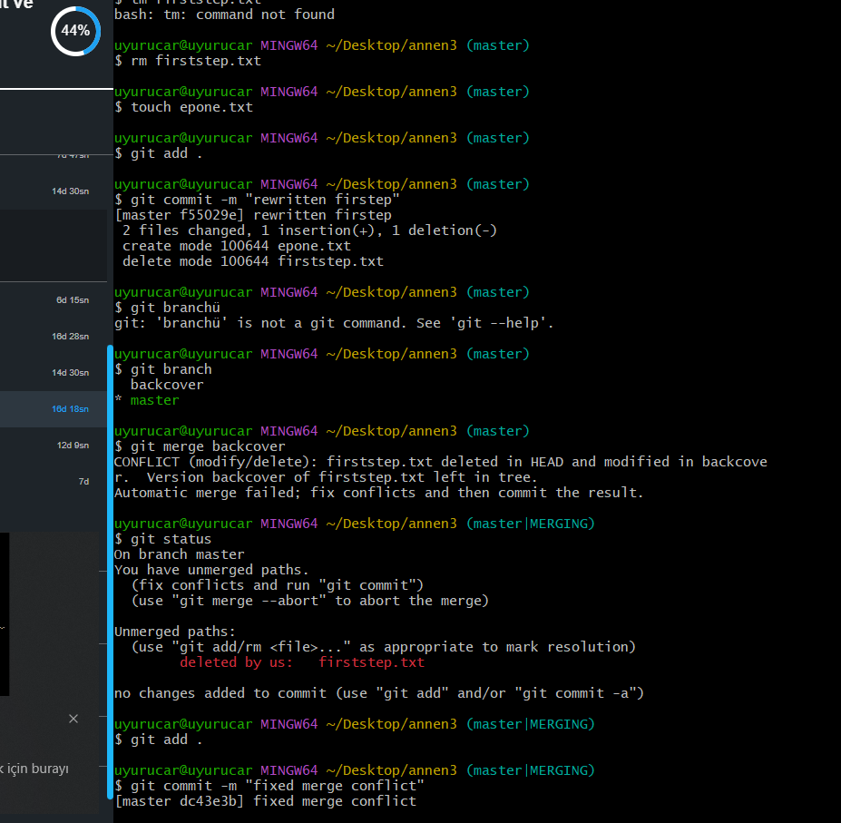
When state is merge conflict (merge|MERGING) changes should be made on the file causing conflict. Then it should be indexed and committed. conflict will resolve.

Stash
When a work in a branch is incomplete and switch to another branch is mandatory, after adding a new file and switching to another branch, that new file stays within the changed branch.
Without committing or adding, changing a file that exists in both branches affect both branches by git moving changes made in branch(B) to branch(A) (or throwing an error and not letting switch branch).
git restore "file.ext" - restores file from last commit
git restore command restores file from last commit AND discards the changes made in branch(B).
Stash is used to store changes without committing or adding.
git stash - stash command
git stash list - shows stash list
git stash apply "ID" - restores exact stash by id
git stash pop - restores changes from stash
git stash clear - deletes all stash
git stash apply - same as pop but stash still remains in the list

Checkout
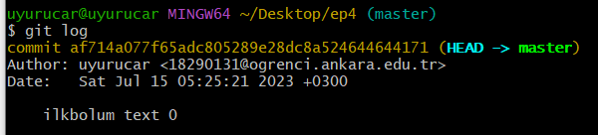
every commit has an id "commit *****"
git checkout "ID" - sets head to specified commit. since last commit is not the head at the moment, this state is called detached head.
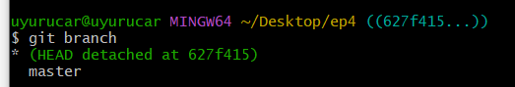

git switch "name" - turns back to original branch

turning detached head into a new branch is possible:
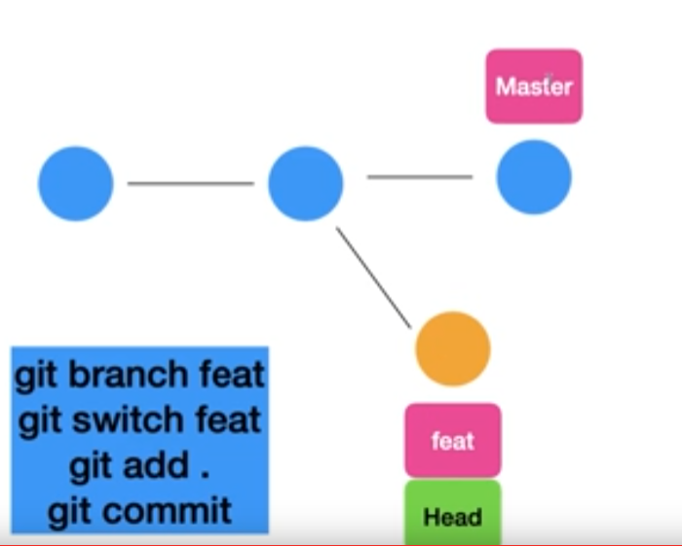
Reset & Revert
git reset "commit id" - sets specified commit as head, deletes commits after that and current state of the project is kept as "unstaged"
git reset --hard "commit id" - --hard keyword forces git to also revert changes from past commits (therefore completely deletes them).

git revert "commit id" - takes back the changes made in the commit and creates a new commit with that version. recommended to revert commits one by one and in order, to avoid merge conflict problems with a colleague.

Git Diff
shows difference between commits.
git diff - unstaged data vs last commit
git diff [commit id] [commit id]
git diff [branch] [branch]

Rebase
after multi-merging from master, rebase function takes both master and current branch commits and creates as a single line. this will corrupt log history and should be careful while using.

git switch [branch]
git rebase [master]

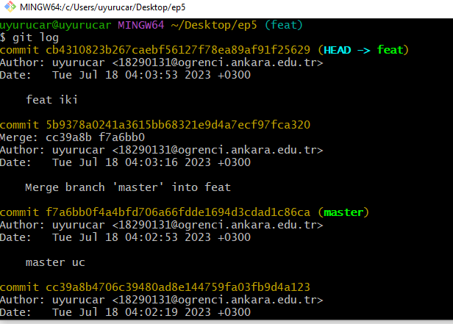
before rebase
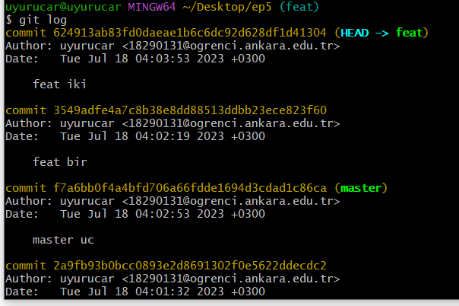
after rebase (merge commits disappeared and dates are out of order)

GITHUB

create and commit in git as usual. then:
git remote add origin [link] - use this remote source as origin
git push -u origin main(master) - push main(master) to origin
(-u : upstream)
git push - after first push git push can be used
git push origin [branch] - pushes another branch

fetch and pull
git branch -r -show remote branches
git fetch origin master - brings remote branch but does not affect local files
git checkout origin/master - brings remote branch, turns into detached head state
git pull origin master - brings remote branch and merges with local branch

clone and fork
git clone [link.git] - clones any repo to local
when a new commit from cloned repo is pushed, git will try to push it to the cloned repo. if user is not authorized, permission will be denied.

Fork is similar to clone, but it clones repo to user's repositories. this new repo can be cloned to local using git bash and new commits can be pushed.

private
github-> settings -> collaborators -> add
collaborators gain push access

